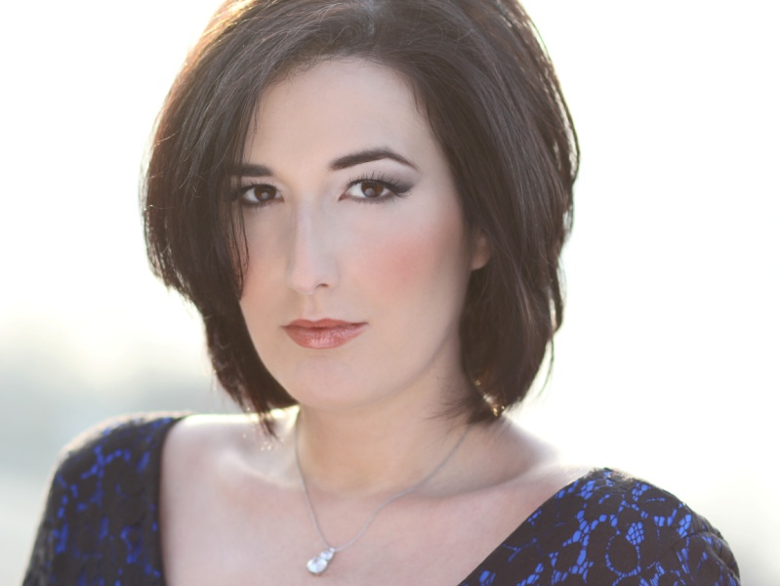
“The singing was uniformly strong, with Zeffin Quinn Hollis and Lisa Chavez working in tandem as a pained, sympathetic John and Elizabeth Proctor.”
Allan Kozinn, New York Times

“As Elizabeth, Lisa Chavez displays a rich, plangent voice and strong connection to the music.”
Ronni Reich, Backstage Magazine

Lisa Chavez
Mezzo Soprano
lisachavez@lisachavez.com
917-332-8329

Upcoming Roles
Meg Page  Hansel  Suzuki  Donna Elvira | Falstaff  Hansel and Gretel  Madama Butterfly  Don Giovanni | Opera San Jose, September 2013  Opera San Jose, November – December 2013  Opera San Jose, February – March 2014  Opera San Jose, April – May 2014
Roles Performed
Madame Larina | Eugene Onegin | Opera Company of Middlebury (2013)
Dinah | Trouble in Tahiti | Opera Parallèle (2013)
Lorca | Ainadamar | Opera Parallèle (2013)
Marie | Most Happy Fella | Dicapo Opera (2012)
Mamma Lucia | Cavalleria Rusticana | Martha Cardona Theater (2012)
Suzuki | Madama Butterfly | Shreveport Opera (2012)
Secretary | The Consul | Dicapo Opera (2012)
Mrs. Bass | Emmeline | Szeged National Theatre, Dicapo Opera (2009)
Zulma  Elizabeth Proctor | L’Italiana in Algeri  The Crucible | National Lyric Opera (2009)  Finals for Mezzo TV Opera Competition, Szeged National Theatre, Pécs National Theater, Dicapo Opera (2008)
Madame Volanges | Dangerous Liaisons | Dicapo Opera (New York Premier 2008)
Gertrude | Roméo et Juliette | Opera New England of Cape Cod (2007)
Kate | Pirates of Penzance | Opera New Jersey (2007)
Carmen | Carmen | Dicapo Opera (2007)
Mercédès | Carmen | One World Symphony, Opera of the Hamptons (2005)
Sensuous Woman | The Proposal | MSM One Act Opera Co. (New York Premier 2004)
Marcellina | Le Nozze di Figaro | One World Symphony (2004)
Dorabella | Cosí fan Tutte | Bay Area Summer Opera & Theater Institute, (2003)
Competitions
Third Prize Irene Dalis Vocal Competition – May 2013
First Place and Audience Choice Irma M. Cooper Vocal Competition – March 2013
Encouragement Award from the Gerda Lissner Foundation - March 2011
4th Place Prize Mary Jacobs Smith Singer of the Year Competition - January 2011
Encouragement Award from Sally and Tony Amato Scholarship Competition - March 2010
Encouragement Award from the Gerda Lissner Foundation - March 2009
Finalist in Opera Competition and Festival with Mezzo Television - November 2008

